**Assignment 01 CCN Theory**

**Spring 2025**

Submitted by: **Mohsin Sajjad**

Registration No: **22pwsce2149**

Class Section: **A**

“On my honor, as student of University of Engineering and Technology, I have neither given nor received unauthorized assistance on this academic work.”

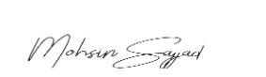

Student Signature: ______________

Submitted to:

**Engr. Ihsan ul haq**

Month Day, Year (08 04, 2025)

Department of Computer Systems Engineering

University of Engineering and Technology, Peshawar

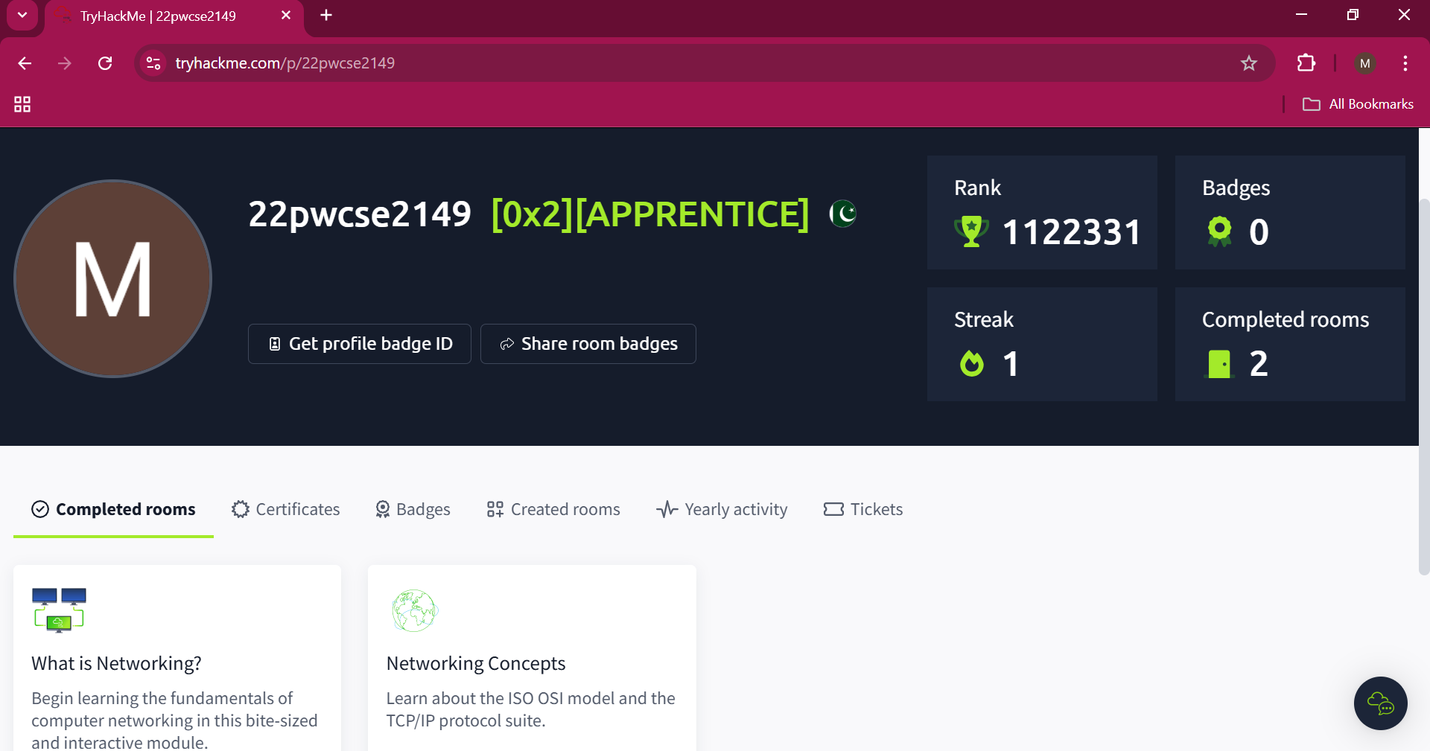

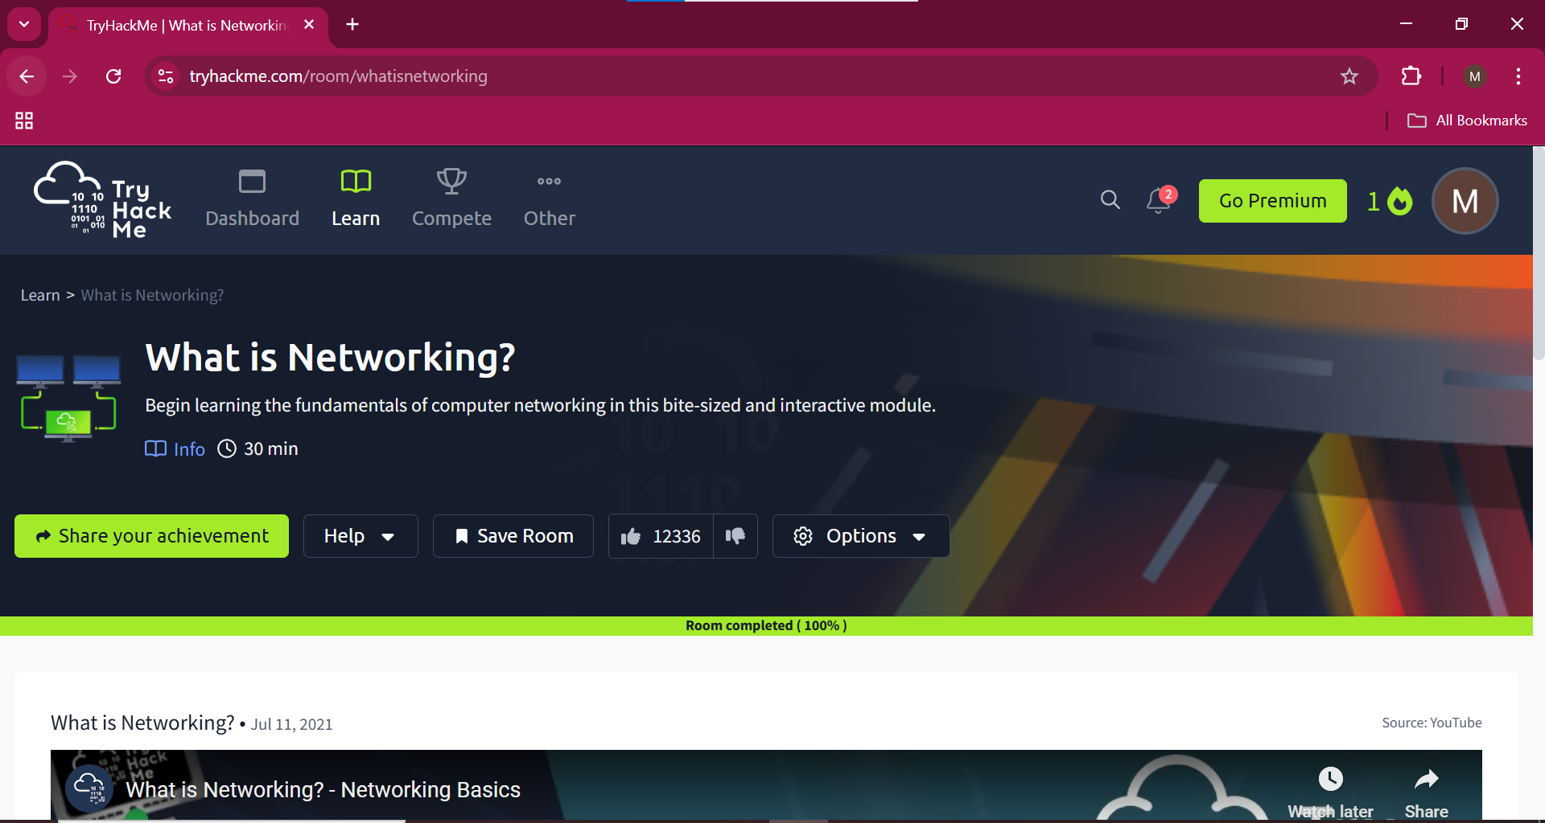

What is the key term for devices that are connected together?

Answer:

Network

Who invented the World Wide Web?

Answer:

Tim Berners-Lee

What does the term "IP" stand for?

Answer:

Internet Protocol

What is each section of an IP address called?

Answer:  
octet

How many sections (in digits) does an IPv4 address have?

Answer:

4

What does the term "MAC" stand for?

Answer:

Media Access Control

What protocol does ping use?  
Answer:

ICMP

What is the syntax to ping 10.10.10.10?

Answer:

ping 10.10.10.10

What flag do you get when you ping 8.8.8.8?

Answer:  
THM{I_PINGED_THE_SERVER}

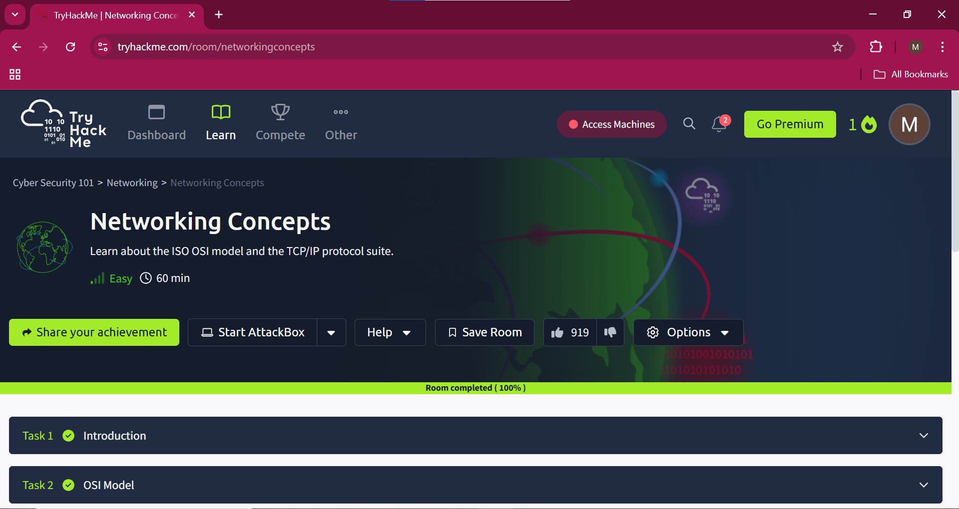

**Which layer is responsible for end-to-end communication between running applications?**

Answer:

4

**Which layer is responsible for routing packets to the proper network?**

Answer:

3

**In the OSI model, which layer is responsible for encoding the application data?**

Answer:  
6

**Which layer is responsible for transferring data between hosts on the same network segment?**  
Answer:  
2

**To which layer does HTTP belong in the TCP/IP model?**  
Answer:  
Application Layer

**How many layers of the OSI model does the application layer in the TCP/IP model cover?**

Top of Form

Answer:

3

**Which of the following IP addresses is not a private IP address?**  
Answer:  
49.69.147.197

**Which of the following IP addresses is not a valid IP address?**

Answer:  
192.168.305.19

**Which protocol requires a three-way handshake?**  
Answer:  
TCP  
**What is the approximate number of port numbers (in thousands)?**

Top of Form

Answer:  
65

**On a WiFi, within what will an IP packet be encapsulated?**  
Answer:  
Frame  
  
**What do you call the UDP data unit that encapsulates the application data?**  
Answer:  
Datagram

**What do you call the data unit that encapsulates the application data sent over TCP?**  
Answer:  
segment

**Use telnet to connect to the web server on MACHINE_IP. What is the name and version of the HTTP server?**

Answer:  
lighttpd/1.4.63  
  
**What flag did you get when you viewed the page?**  
Answer:  
THM{TELNET_MASTER